DBA | Implementation of the FRP application
Implementation Guide

Table of Contents
1. Implementation 3
1.1. Backup 3
1.2. Deployment Proper 3
1.3 Rollback (Optional – in case of failed deployment) 4
2. Test / Verification 5

INTRODUCTION

Implementation

Backup
N/A

Deployment Proper

- Connect to FRP UAT Application server (RSRSPW22AVM01 / 172.25.189.2)

For UNI:

- Go to Drive D and create new folder named “FRP_UNI”
- Get all the files in the TFS below and paste it to the newly created FRP_UNI folder.
TFS path: \\ewbtfsappsm01\ITG-TFS\SDD1\OneSumX\PROD\FRP Application\Initial Deployment - 11.11.2026\FRP_UAT_UNI

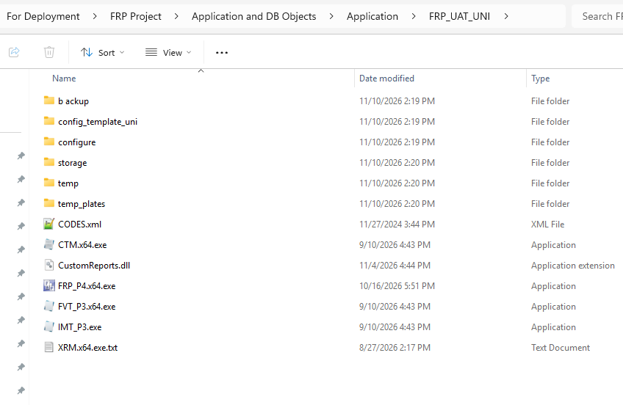

- Double-click the CTM.exe.

- On the left pane, click the Name:
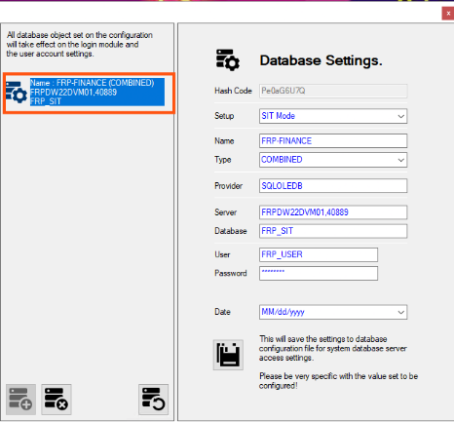

- Update the changes to be made on the module:
  - Provider – SQLOLEDB
  - Server – RSRSPW22DVM01, 40889
  - Database – FRP_UNI
  - User – frp_db_user
  - Password – (to be inputted by sysad and dcd)

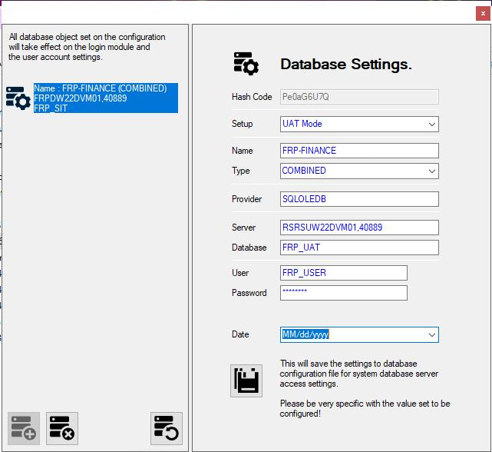

- Click the SAVE button to save the changes.
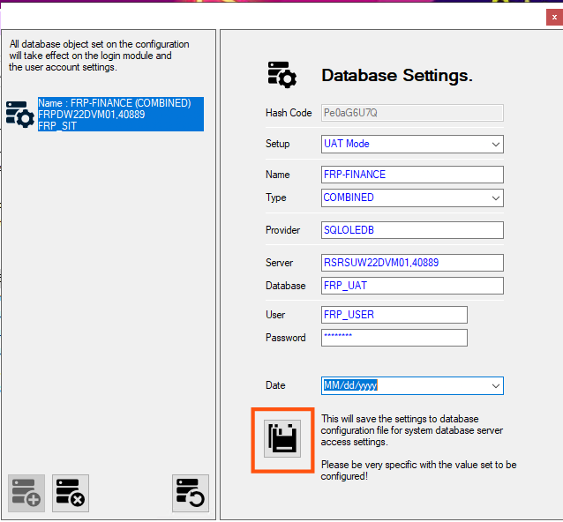

- The changes will take effect immediately by running the FRP system.

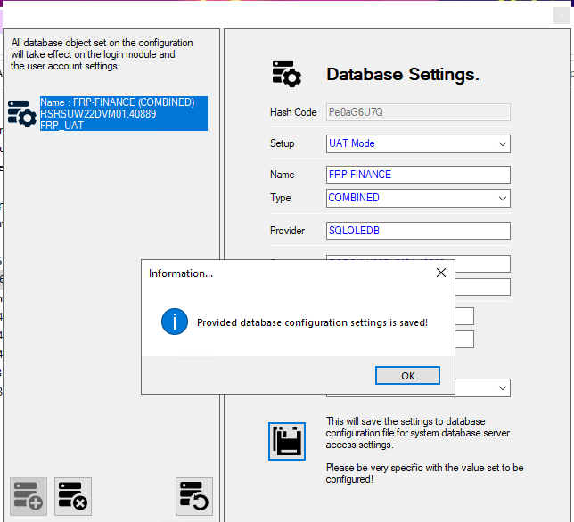

For RB:

- Go to Drive D and create new folder named “FRP_RB”
- Get all the files in the TFS below and paste it to the newly created FRP_RB folder.
TFS path: \\ewbtfsappsm01\ITG-TFS\SDD1\OneSumX\PROD\FRP Application\Initial Deployment - 11.11.2026\FRP_UAT_RB

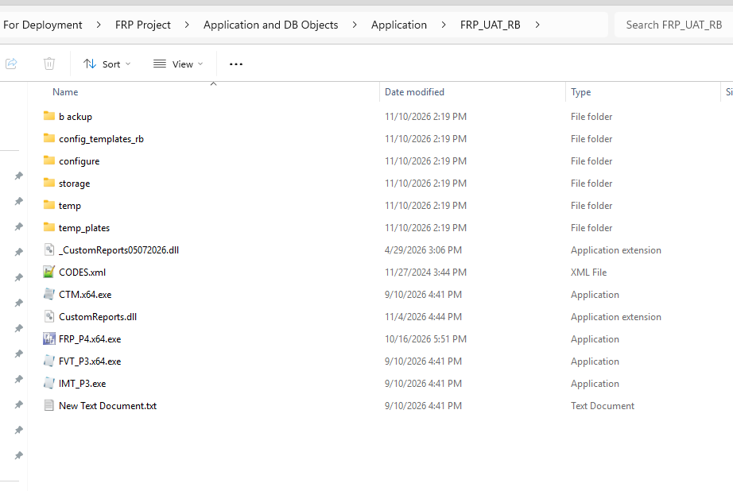

- Double-click the CTM.exe.

- On the left pane, click the Name:

- Update the changes to be made on the module:
  - Provider – SQLOLEDB
  - Server – RSRSPW22DVM01, 40889
  - Database – FRP_RB
  - User – frp_db_user
  - Password - (to be inputted by sysad and dcd)

- Click the SAVE button to save the changes.

- The changes will take effect immediately by running the FRP system.

- Configure Shared Folder for UNI

  - Right Click on the Application Folder (D:\FRP_UNI) then click Properties.

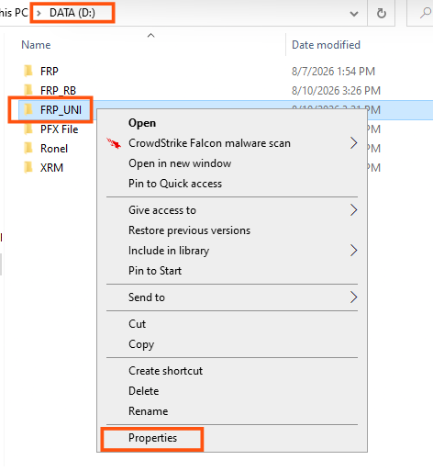

  - Go to Sharing Tab, then click Advanced Sharing
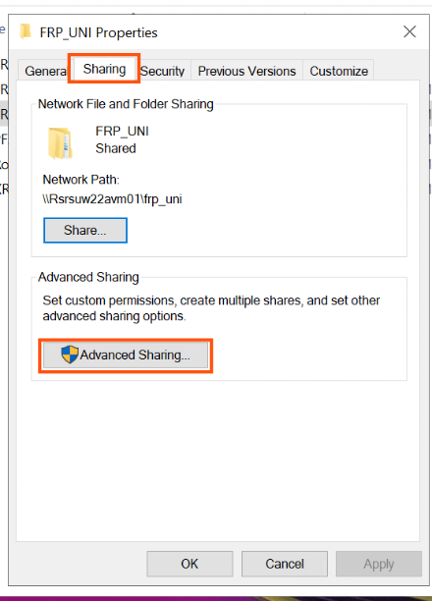

  - In the Advanced Sharing window, check the “Share this folder” then click “Permissions”
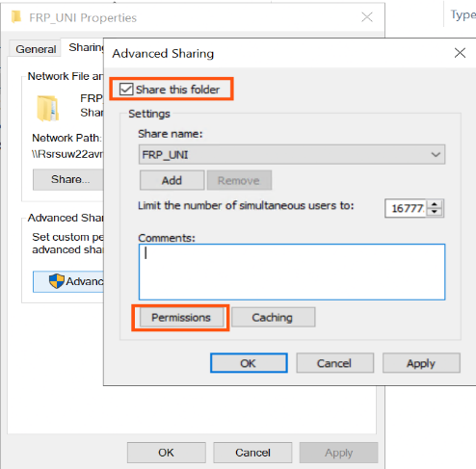

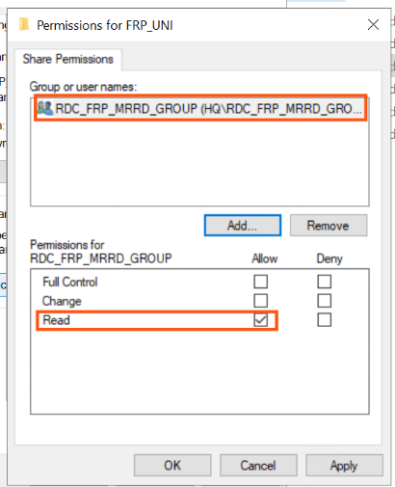
  - Add Sec Group RDC_FRP_MRRD_GROUP with Read permission.

  - Once done, click “Apply” then click “OK”. (Twice)
  - In the Folder properties again, go to “Security Tab”, then click “Edit”
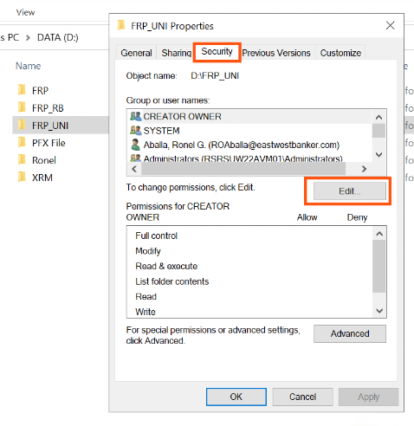

  - Click Add button and Add Sec Group RDC_FRP_MRRD_GROUP with Read & Execute, List folder contents, and Read permission.

Once done, click “Apply” and “OK”

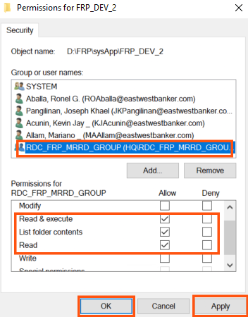

  - In the security settings again, click “Advanced” button.
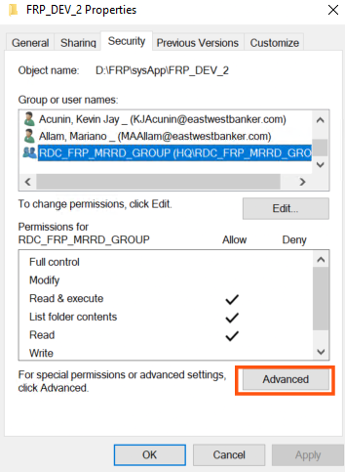

  - In the Advanced Security settings, click on the Sec Group RDC_FRP_MRRD_GROUP then click, “Edit”

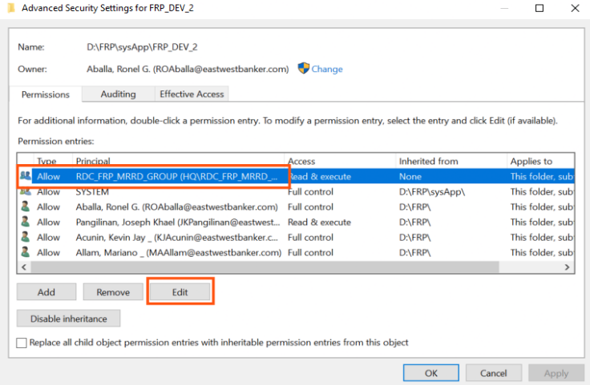

  - Click “Show advanced permissions” and make sure the following permissions below and “Checked”
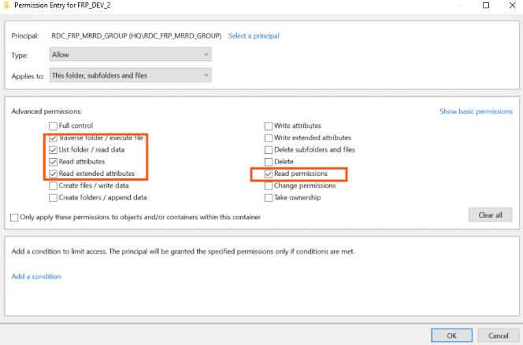

  - Double click on D:\FRP_UNI folder, right click on “config_template_uni”

Then click “Properties”
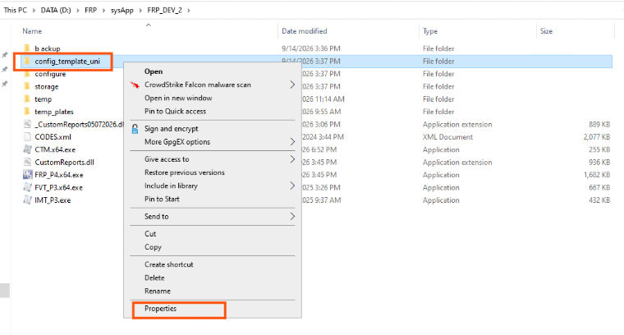

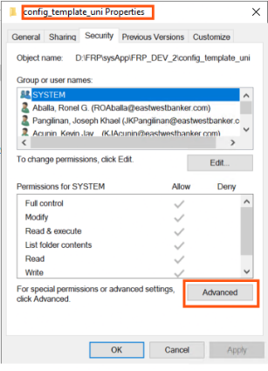
In the Properties window, click “Advanced”.

In the Advanced Security settings, click “Disable Inheritance” then click
“Convert inherited permissions explicit on this object”.

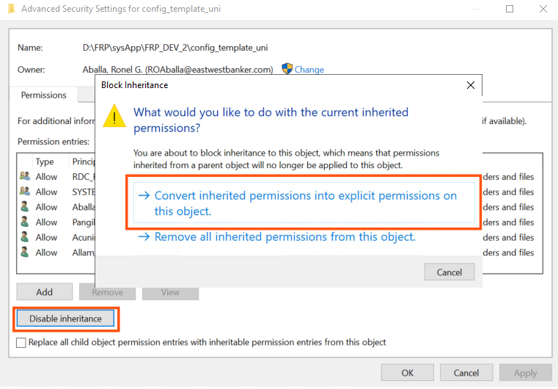

click on the Sec Group RDC_FRP_MRRD_GROUP then click, “Edit”
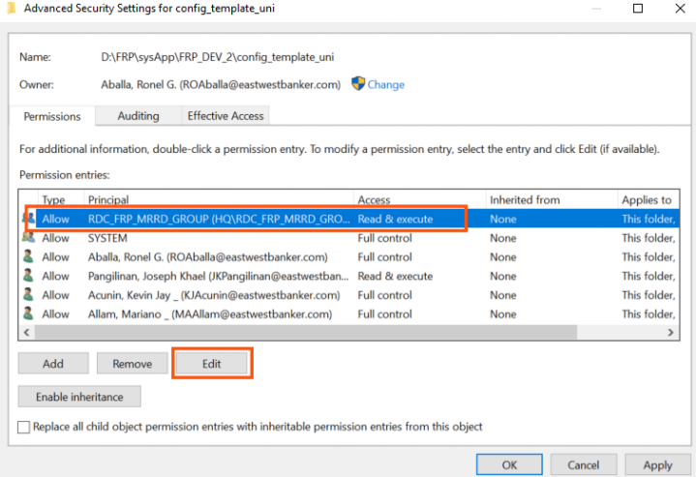

Click “Show advanced permissions” and make sure the following permissions below and “Checked”, once Done, click OK.
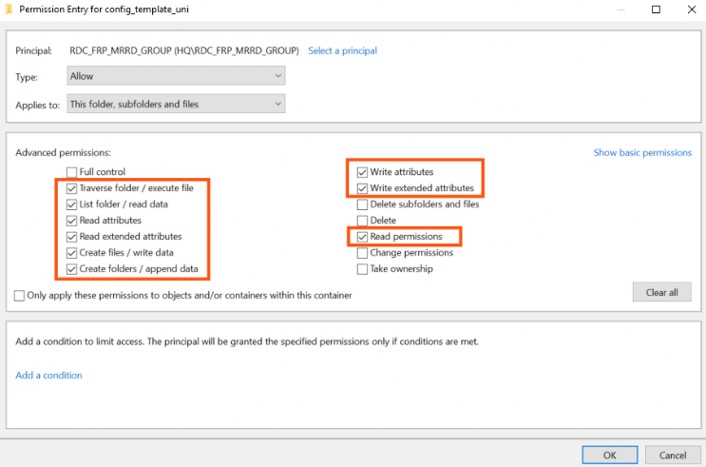

Click “Apply” button then click “OK”
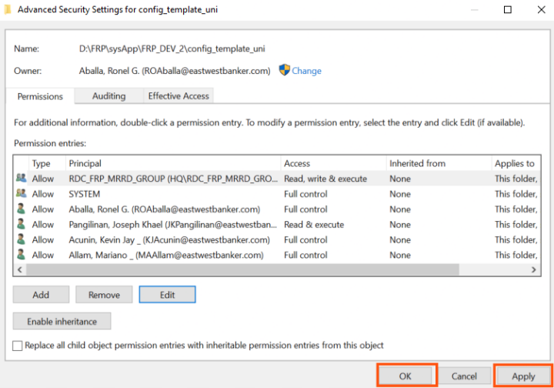

Click on “Sharing” tab, and click “Advanced Sharing”
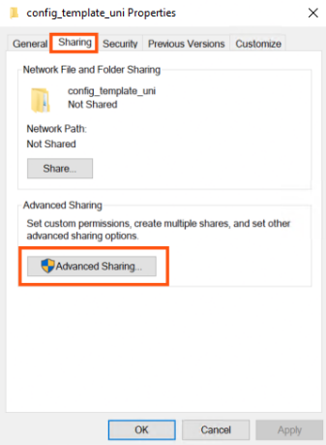

Check the option “Share this folder”, and click “Permissions”
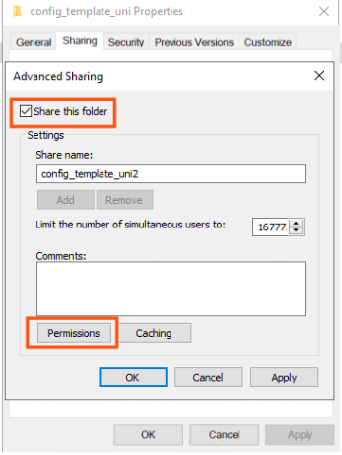

Click the “Everyone” then click “Remove” button.
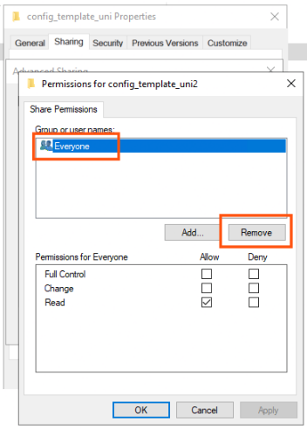

Add Sec Group RDC_FRP_MRRD_GROUP with the permission “Read” and “Change”.

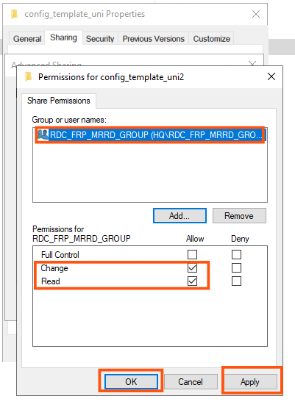
Once done, click “Apply”, then “OK” twice.

- Configure Shared Folder for RB

Follow the same instructions above for the FRP_RB folder regarding shared folder configuration and access permissions.

Rollback (Optional – in case of failed deployment)

- Review the credentials and repeat the deployment process.

Test / Verification

- Run the FRP application, should not have error while running:
- Scan
- Validation
- XML Conversion

